**Software Engineering Tools Lab Assignment No-9**

(Module 5- Software testing using tools) **Due date-20/04/2023**

Q 1. What are the prerequisites for installing the Selenium.

1. Java Development Kit (JDK): Selenium requires JDK to be installed on your machine to execute test scripts. You can download the latest version of JDK from the official Oracle website.
2. Integrated Development Environment (IDE): You need an IDE to write and execute Selenium test scripts. Some of the popular IDEs are Eclipse, IntelliJ IDEA, and NetBeans. You can download and install any IDE of your choice.
3. WebDriver Language Bindings: Selenium supports multiple programming languages like Java, Python, C#, Ruby, and more. You need to download the WebDriver language bindings for the programming language you will use to write the test scripts.
4. Selenium Server or Standalone Server: Selenium Server is required when you want to execute tests remotely on different browsers and operating systems. You can download the Selenium Server from the official Selenium website.
5. Browsers: You need to have the web browsers installed on your machine on which you want to execute the test cases.
6. Web Application: You need a web application or website on which you want to execute the test cases.

Q 2. Install Selenium tool on your machine (Provide screen shots for successful installation and login)

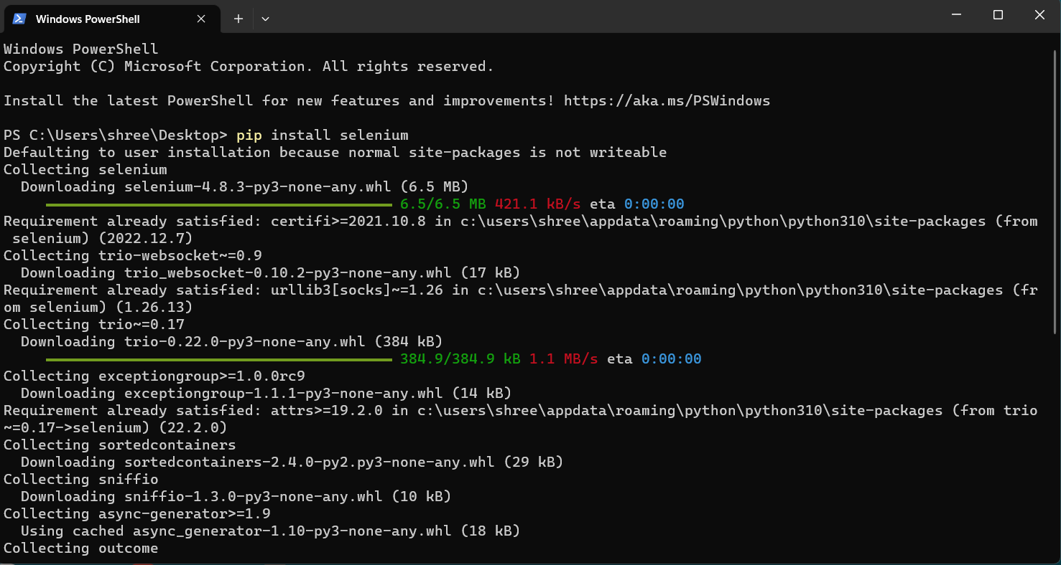

Q 3. Using Selenium tool create multiple test cases (at least 10) on any application/project that you have implemented.

Perform below tasks

1. Create New test project as SETProject

1. Create a test plan as SETProjectTestPlan

1. Create a build as SETProjectBuild

1. Create test suite as Test Suite 1 under SETProject

1. Create Test cases in Selenium Tool

from selenium import webdriver

from selenium.webdriver.common.keys import Keys

# Set up the driver for your preferred web browser

driver = webdriver.Chrome()

# a. Create a new test project as SETProject

driver.get("https://www.your-test-project-website.com/create")

project_name = driver.find_element_by_id("project_name")

project_name.send_keys("SETProject")

create_button = driver.find_element_by_id("create_project_button")

create_button.click()

# b. Create a test plan as SETProjectTestPlan

driver.get("https://www.your-test-project-website.com/SETProject/testplans/create")

test_plan_name = driver.find_element_by_id("test_plan_name")

test_plan_name.send_keys("SETProjectTestPlan")

create_button = driver.find_element_by_id("create_test_plan_button")

create_button.click()

# c. Create a build as SETProjectBuild

driver.get("https://www.your-test-project-website.com/SETProject/builds/create")

build_name = driver.find_element_by_id("build_name")

build_name.send_keys("SETProjectBuild")

create_button = driver.find_element_by_id("create_build_button")

create_button.click()

# d. Create a test suite as Test Suite 1 under SETProject

driver.get("https://www.your-test-project-website.com/SETProject/testsuites/create")

test_suite_name = driver.find_element_by_id("test_suite_name")

test_suite_name.send_keys("Test Suite 1")

create_button = driver.find_element_by_id("create_test_suite_button")

create_button.click()

# e. Create test cases in Selenium Tool

driver.get("https://www.your-test-project-website.com/SETProject/TestSuite1/testcases/create")

# Use Selenium to fill in the test case details, such as name, description, steps, and expected results

create_button = driver.find_element_by_id("create_test_case_button")

create_button.click()

# Close the browser

# driver.quit()

